

Next Generation On Demand (NGOD)

Content Locate and Transfer Protocol – C2

D03W02
July 7, 2009

Document Status Sheet
Document Title: | Content Locate and Transfer Protocol – C2
Revision History: | July 7, 2009  - Changed from “port” to “resource”  - Swapped the order of some sections.  - Standardize the description of the XML elements.  - Added Available Range and Open For Write elements.  - Clarify some and added some other response codes.  - Reformatted the examples and added a request example using an internal identifier  Apr 15, 2009  - Updated the URI for the Content Transfer Request  - Host header identifiers the HTTP server, not the client.  - Clarified the XML example for VOD Object.  - Corrected chunked example.  December 15, 2008 – Editorial clean-up  Nov 21, 2008  - Transfer Delay is only used in content locate message.  - Need to use a root element to enable the typical XML tools.  - Transfer ID is not limited to 32 hex digits.  - After more reflection and study if we use the HTTP protocol we must use the HTTP URI.  - Deleted Open Items appendix – they all appear to be addressed.  - Updated discussion of relationship between byte range and the start of the file.  - Examples show a multiple chunk response.  - In order to increase acceptance of the specification with external standards body use headers and URI for protocol related issues and message body for application layer issues.  Oct 2, 2008  - Range header value differences with the HTTP standard more clearly delineated.  - Removed Client Control header. Changed Transfer Terminate header to Transfer ID Delete.  Sept 12, 2008  - Exclusion List header is optional.  - Added Client Control header to examples.  Sept 8, 2008 – Initial Draft release
Date: | July 7, 2009
Status: | Work in Progress | Draft | Issued | Released
Distribution Restrictions: | VE Authors Only | VE & PE members only | Suppliers | None

Key to Document Status Codes:
Work in Progress (W) | An incomplete document, designed to guide discussion and generate feedback that may include several alternative requirements for consideration.
Draft (D) | A document in specification format considered largely complete, but lacking review by other VE and PE vendors. Drafts are susceptible to substantial change during the review process.
Issued (I) | A stable document, which has undergone rigorous VE & PE vendor review and is suitable for product design and development, cross-vendor interoperability, and for certification testing.
Released (R) | A stable document, reviewed, tested and validated, suitable to enable cross-vendor interoperability.
Contents
1 SCOPE 6
1.1 Introduction and Overview 6
1.2 Scope 6
1.3 Requirements (Conformance Notation) 6
2 ReferenceS 7
2.1 Normative References 7
2.2 Informative References 7
3 Terms and Definitions 8
4 Abbreviations and acronyms 9
Table 1 - Abbreviations and Acronyms 9
5 Overview 10
5.1 C2 Protocol Flow 10
6 LocatING CONTENT 13
6.1 Locate Request 13
6.1.1 Client Transfer 13
6.1.2 Exclusion List 13
6.1.3 Ingress Capacity 14
6.1.4 Object 14
6.1.5 Range 15
6.1.6 Transfer Delay 16
6.1.7 Transfer ID Delete 17
6.1.8 Transfer Rate 17
6.2 Locate Response 18
6.2.1 Available Range 18
6.2.2 Open For Write 18
6.2.3 Transfer ID 18
6.2.4 Transfer Port 19
6.2.5 Transfer Timeout 19
7 Message Headers 20
7.1 Ingress Capacity 21
7.2 Range 21
8 HTTP CONSIDERATIONS 23
8.1 Introduction 23
8.1.1 Request Message 23
8.1.2 Response Messages 23
8.1.3 HTTP Request-Response 24
8.1.4 Lost Connection 24
8.1.5 Request Timeout 24
9 C2 Message Examples 26
9.1 Use Cases 28

List of Tables
Table 1 - Abbreviations and Acronyms 9
Table 2 – C2 Header Field Usage 20
Table 3 – HTTP Response Codes 23
List of Figures
Figure 1 – VOD Object Content Locate Request 26
Figure 2 – VOD Object Content Locate Request 27
Figure 3 –Content Locate Response 27
Figure 4 –Content Transfer Request 27
Figure 5 –Content Transfer Response 27
Figure 6 –Content Transfer Response – Expired Reservation 28
Figure 7 –Content Locate Request – Remove Reservation 28
Figure 8 –Content Locate Request – Remove Reservation 28
Figure 9. Use Case 1 – Content Locate and Transfer Flow 29
Figure 10. Use Case 2 - Transfer Refusal and Subsequent Locate/Transfer 30

SCOPE

Introduction and Overview
This document describes the functional requirements, interfaces, and message structure of the Content Locate and Transfer Protocol (C2) component of the NGOD CDN system.

Scope
The scope of this document is the functionality and detailed definition of the Content Locate and Transfer Protocol of the Comcast CDN system.

Requirements (Conformance Notation)
Throughout this document, the words that are used to define the significance of particular requirements are capitalized. These words are:
“MUST” | This word or the adjective “REQUIRED” means that the item is an absolute requirement of this specification. The word “MANDATORY” may be used in lieu of “MUST” in certain circumstances.
“MUST NOT” | This phrase means that the item is an absolute prohibition of this specification.
“SHOULD” | This word or the adjective “RECOMMENDED” means that there may exist valid reasons in particular circumstances to ignore this item, but the full implications should be understood and the case carefully weighed before choosing a different course.
“SHOULD NOT” | This phrase means that there may exist valid reasons in particular circumstances when the listed behavior is acceptable or even useful, but the full implications should be understood and the case carefully weighed before implementing any behavior described with this label.
“MAY” | This word or the adjective “OPTIONAL” means that this item is truly optional. One vendor may choose to include the item because a particular marketplace requires it or because it enhances the product, for example; another vendor may omit the same item.

ReferenceS

Normative References
This section contains those documents that are required for understanding this document. These referenced documents may contain requirements that are implicitly included in this document.
[ADI1.1] CableLabs Asset Distribution Interface Specification, Version 1.1 (ADI 1.1), CableLabs, MD SP ADI1.1-I04-060505, June, 2005
[VOD1.1] CableLabs VOD Metadata Content Specification, Version 1.1, CableLabs, MD-SP-VOD-CONTENT1.1-I05-060831
[HTTP1.1] RFC 2616, Hypertext Transfer Protocol -- HTTP/1.1
[URI] RFC 3986, Uniform Resource Identifier (URI): General Syntax
[NGOD-CDN-ARCH] Comcast Next Generation On Demand, CDN Requirements, Architecture, and Use Cases, D01, July, 2008
[NGOD-SO-ALS] NGOD 2.0 Asset Library Service Architecture and Interfaces, Issued 01, April, 2008

Informative References
This section contains those documents that are useful for understand this document. These referenced documents may contain requirements that are explicitly included in this document; however, no requirements in these documents will be implicitly included in this document.
[NGOD-GEN-ARCH] Next Generation On Demand Overall Architecture – January 2006
[NGOD-CDN-SUB] Next Generation On Demand Standard VOD Object Subtypes; D01; Sept 17, 2008
[ADI2.0-CONTENT] Video-On-Demand Content Specification Version 2.0, CableLabs, MD-SP-VOD-CONTENT2.0-I02-070105, January 5, 2007

Terms and Definitions

Abbreviations and acronyms
This requirements document uses the following abbreviations and acronyms:

Table 1 - Abbreviations and Acronyms

ADI | Asset Distribution Interface
AMS | Asset Management System
CBR | Constant Bit Rate
CDN | Content Delivery Network
CLS | Content Library Service
CLTP | Content Locate and Transfer Protocol
CPM | Content Propagation Manager
DHCP | Dynamic Host Configuration Protocol
FQDN | Fully Qualified Domain Name
HTTP | Hypertext Transfer Protocol
IP | Internet Protocol
IPv4 | Internet Protocol Version 4
IPv6 | Internet Protocol Version 6
JPEG | Joint Photographic Experts Group
PAID | Provider Identifier and Asset Identifier
SLA | Service Level Agreement
VBR | Variable Bit Rate
VOD | Video On Demand
TCP | Transmission Control Protocol
UDP | User Datagram Protocol
URI | Uniform Resource Identifier
URL | Uniform Resource Locator

Overview
The Content Delivery Network (CDN) content locate and content transfer protocol (C2) is a real time transfer protocol that enables a client to transfer any byte range of any file from the CDN. The C2 protocol implements the content location and content transfer service of the CDN. One type of client utilizing the C2 protocol is a VOD Streaming Server with real time caching and streaming functionality.
C2 supports the transfer of any byte range of a file. Multiple files may be correlated to a single object. For example, a video object may consist of index, 1x, and trick files used to support VOD services, or a JPEG object may consist of multiple JPEG files used to support client enabled applications.
This document details how to locate and transfer files correlated with a VOD object in the CDN. The VOD object may be either static (pre-ingested by CDN prior to being located/transferred) or dynamic (concurrently being ingested by CDN and located/transferred). Future revisions of this document will define methods for locating and transferring files associated with other types of objects.
The C2 protocol supports both locate and transfer functionalities. The following functions are supported:
A content locate function that responds with the content transfer interface that is best suited to provide the content transfer operation based on the request. The CDN chooses the optimal transfer interface based on the client request.
A content transfer function that transfers the content from the CDN to the client using the specified content transfer parameters (bit rate, client ingress capacity, byte range, etc).
In addition to these functions, a service locate function is required to find an appropriate IP address to use to contact the CDN. Two options for the service locate function are static provisioning within the client, potentially via a DHCP type of provisioning file, or FQDN-based DNS lookup to find topologically close CDN interfaces. Future enhancements to the C2 protocol may allow for dynamic service location.

C2 Protocol Flow
The CDN supports two resources, a Locate resource and a Transfer resource. By adopting the HTTP concept of resources allows the CDN to be comprised of multiple physical devices in multiple locations while presenting itself to client devices with a single identity.
The Locate resource is defined as an IP address that is learned via a service locate function, either manually configured on the client or dynamically learned by a DNS or other dynamic lookup mechanism. A TCP connection MAY be maintained with the Locate resource and reused for subsequent content location requests by a given client. Separate multiple concurrent connections MAY be used.
The Transfer resource transfer files from the CDN. Its URL is conveyed to the client via the response to the content locate function. The content locate function also returns a unique Transfer ID used to correlate transfer requests to the locate request. The client includes this Transfer ID in the transfer request(s). The Transfer ID will be valid for limited time such that the CDN can optimally manage its resources. The Transfer resource URI and Transfer ID are returned in the response to the content locate function and are not known to the client until after the function is performed.
The interaction between the client and the CDN is as follows:
The client determines the IP address of the Locate resource via service locate mechanisms as described above.
The client sends a content locate request (HTTP POST) to the Locate resource of the CDN. The content locate request includes an identifier of the file along with the requested transfer rate, byte range, transfer start delay, and available bandwidth on the client’s receive interface.
The content locate response includes the URI of the content Transfer resource and a Transfer ID. The Transfer ID, also referred to as a reservation, will only be valid for a short time after the content locate function is completed. The content transfer function must be initiated within this specified time period. If the client fails to initiate the content transfer within that period, the request to transfer content will be refused by the CDN and the content locate function will need to be reissued. The time value is determined by the CDN to allow it to maintain optimization of its resources.
The client makes a content transfer request to the Transfer resource using the Transfer ID along with parameters that define the characteristics of the transfer.
Content is transferred to the client using chunked transfer coding, as specified in [HTTP 1.1].
The transfer terminates in one of two ways:
- The content transfer completes as signaled by a GET response with a zero (0) length chunk.
- The client or CDN issues a TCP reset.
When a specific content transfer request completes via any method (including a loss of connection because of network error), the reservation timer is reset, and the client MAY reissue a content transfer on the same reservation at the same rate as long as the new range for content to be transferred are bounded by the range specified in the initial content location request.
The C2 protocol enables transfer of an arbitrary number of file segments at arbitrary offsets and ranges fulfilling either real-time or best-effort service level agreement as requested by the client. No constraint is defined as to the number of simultaneous transfers that can be active for a given file, or how the transfers are associated with the client’s caching and streaming behavior.
The C2 protocol enables the index file of a VOD asset to be independently transferred so that any correlated file segment range identified by the index file may be subsequently transferred. An index file associated with a fixed-length asset will be fully transferred in continual uninterrupted chunks until the full file is transferred using the specified rate profile. An index file associated with a dynamic-length object, such as a live time-shifted recording, will be periodically updated in chunks, with zero bandwidth gaps, for the life of the ingest (e.g. a one hour time-shifted asset for which content transfer begins near the beginning of ingest will periodically push out update chunks for the next hour). The completion of the transfer of any object, dynamic-length or fixed-length, is defined by the receipt of a zero length chunk.
The C2 protocol enables both best effort and constant bit rate transfers. At-rate transfers are typically requested by clients when the content is a video file that is encoded at a specific playout bit rate. For example, if according to the index file a video file is CBR-encoded at 3.75Mbps, then the client SHOULD request the file at that rate. Depending on the parameters defined below the CDN will either transfer the file to the client at the requested rate after a short burst above rate at time of the request or at the requested rate if a transfer delay is specified. In both cases the client’s requested elasticity buffer size will be accommodated. The initial burst rate to populate the client elasticity buffer is chosen by the CDN and will be no greater than the Client Ingress Capacity value indicated in the client request and no less than the content’s requested bit rate.
If a transfer is requested in best effort mode, then the CDN will transfer the file at a rate not to exceed the aggregate available client ingress capacity. The transfer rate may change during the duration of the transfer. To avoid surges which meet average bit rates over the long term but overrun client buffers instantaneously, the CDN transfer rate MUST NOT exceed the Client Ingress Capacity when measured across any five millisecond (5 ms) time period.

LocatING CONTENT
Locating content on the CDN is accomplished through an HTTP POST. Both the request and response contain and XML document that define content to be transferred.
Devices external to the CDN refer to files or objects with well-known identifiers that are specific to individual services or applications. The CDN supports clients for multiple applications, services and object types. Rather than try and anticipate all possible identifiers for the files, the content locate function uses the Request-URI (term defined in [HTTP1.1]) is used to identify the Name Space for the object with. The object identifier contained is contained within the XML document within content locate request.
This section defines the two (2) different XML documents used in locating content: Locate Request and Locate Response.

Locate Request
The Locate Request element defines an XML document for requesting or canceling a reservation.
The Locate Request element contains no attributes.
The Locate Request element may contain the following sub elements: Client Transfer, Exclusion List, Ingress Capacity, Object, Range, Transfer Delay, Transfer ID Delete and Transfer Rate.

Client Transfer
The Client Transfer element is used to inform the CDN that the client architecture uses different addresses for content locate and content transfer requests. This header allows the CDN to correctly track the ingress capacity between content locate and content transfer requests.
If no Client Transfer element is included in a request, then the CDN will use the source address of the IP packet.
The Client Transfer element contains no attributes.
The Client Transfer element contains no sub elements.
The character data within this element MUST be an address in either IPv4, or IPv6 notation. White space MUST be ignored in this data.

Exclusion List
The Exclusion List element is used to inform the CDN of Transfer Ports that are unacceptable to the client for content transfer resulting from the current content locate request.
No constraint as to the utilization of this element is defined. One possible use case is where the client determines that the SLA delivered by the CDN from a given Transfer Port is not sufficient, and thus a subsequent content transfer should be initiated from a different IP address.
The Exclusion List element contains no attributes.
The Exclusion List element contains no sub elements.
The character data within this element MUST be a comma separated list of addresses. An address MUST be in either IPv4, or IPv6 notation, however, when multiple addresses are included each address MUST be in the same notation. Dangling commas MUST cause the list and therefore the content locate request to be rejected. White space MUST be ignored in this data.

Ingress Capacity
The Ingress Capacity element is used to inform the CDN of the aggregate capacity guaranteed by the client for all content transfer requests from its content transfer address.
The client is responsible to ensure that its advertised ingress capacity is adequate and available for the life of all requested transfers. The CDN is responsible to ensure that the aggregate bandwidth consumed by all content transfer operations does not exceed the advertised client ingress capacity.
The CDN will compute the aggregate available bandwidth based on the client ingress capacity value in each new content locate or content transfer request. If the requested transfer rate cannot be accommodated based on the specified ingress capacity on the specified content transfer address, then the CDN will respond with a refusal.
The Ingress Capacity element contains no attributes.
The Ingress Capacity element contains no sub elements.
The character data within this element MUST be an unsigned decimal number indicating the capacity in bits per second.

Object
The CDN supports clients for multiple applications, services and object types. Rather than try and anticipate all possible identifiers for the files, the content locate function uses the Request-URI (term defined in [HTTP1.1]) to identify the name space for the object to be located. Within this name space, a specific object identifier is contained within the Object element of the request.
The Object element contains no attributes.
The sub elements contained within the Object element are dependent on the type of object (as defined by the Request-URI). This specification only defines the sub elements for an VOD Object.
An Object element MUST never be in the same Locate Request as a Transfer ID Delete element.

VOD Object
The Name Space for VOD Objects is encoded with a Request_URI of /vodadi.
A VOD Object correlates multiple files. Each file is a subtype of the VOD Object. The identifiers for all subtypes other than the index file subtype are contained in the index file. The index file SHOULD be read to find the identifier that can then be placed in the Object element to locate a specific file. The identifier will be well formed XML and MUST be placed into the Object element with no additional processing. There MUST NOT be any other validation performed.
When not using the identifier from the index file, sub elements are used in the Object element. The two sub elements are Name and Subtype.

Name
The Name element contains the external identifier for the VOD Object.
The Name element contains no attributes.
The Name element contains the following subelements Asset ID and Provider ID. The character data for these sub elements are the values of the provider identifier and asset identifier from the ADI metadata respectively.

Normal Rate Forward Subtype
The Subtype element contains the external identifier for a subtype within the VOD Object.
The Subtype element contains no attributes.
The Subtype element contains no sub elements.
The character data within the element MUST be either index (if the index file is to be located), or forward/1 (if the normal rate forward file is to be located).
The normal rate forward file can also be located using the identifier from within the index file. However, the subtype definition was added to allow a lower latency in accessing the base asset by removing the need to first read the index file.

Range
The Range element is used to inform the CDN of the inclusive byte range of a file to be located for subsequent transfer by the client.
This element allows for optimization of the transfer when the client knows it will not need to transfer an entire file. When this element is used the client MAY request the transfer of any byte range that is a valid subset of this range. The client MUST NOT request multiple byte ranges in a single content location request. The client MAY specify a byte range that extends beyond the end of the file.
A suffix byte range allows the client to request a range of bytes relative to the end of the file. This can be useful when either byte offset is not known.
The Range element contains no attributes.
The Range element contains no sub elements.
The character data within this element MUST be interpreted according to the following ABNF.
c2-byte-range-set = (byte-range-spec | suffix-byte-range-spec)

byte-range-spec = first-byte-pos “-“ [last-byte-position]
suffix-byte-range-spec = “-“ suffix-length

first-byte-pos = 1*DIGIT
last-byte-pos = 1*DIGIT
suffix-length = 1*DIGIT

Transfer Delay
The Transfer Delay is an indication of the time delay from when the client sends the content transfer request and the first byte of the transfer should arrive at the requested transfer rate. In order to fill an elasticity buffer this can be a negative delay, indicating that the client desires a specific amount of data as quickly as possible.
A positive Transfer Delay indicates that the CDN will treat the request as a transfer start delay that can occur up to thirty (30) seconds in the future. At Transfer Delay time after the transfer request, the CDN will begin transferring the file at the requested transfer rate.
If the client desires an elasticity buffer of n seconds, it should set the Transfer Delay to n seconds less than the time it will actually start the stream. This extends to the case where the resulting Transfer Delay is negative by as much as four (4) seconds. If the Transfer Delay would require a larger negative value, then the elasticity buffer is too large to be supported.
Thus a negative Transfer Delay value indicates that the client wishes to use an elasticity buffer, but start its outgoing stream before the CDN could fill the buffer at the requested transfer rate. In this case the CDN will initiate transfer immediately and will attempt to transfer the file above the requested rate in order to catch up to where it would be if it had begun transferring data at the requested bit rate at the requested time (which is before the time of the transfer command).
Algorithmically, in all cases, if:
t is the current time,
t₀ is the time of the transfer request,
t_{D} is the requested delay,
R is the requested transfer rate,
D is the amount of data transferred so far
The CDN will attempt to transfer such that D = R* (t-(t₀+t_{D})), D>0
Thus, in cases where t_{D} is negative, the CDN will have to transfer at higher rate until the equation is satisfied.
The Transfer Delay element contains no attributes.
The Transfer Delay element contains no sub elements.
The character data within this element must be interpreted as a signed decimal number between -4000 and 30000 that indicates the milliseconds of requested delay.

Transfer ID Delete
The Transfer ID Delete element is used to inform the CDN to remove a Transfer ID from the current resource reservations.
This element allows the client to remove unneeded reservations from the calculation of outstanding bandwidth reservations on a client transfer interface.
This header is used only to remove outstanding bandwidth reservations on the CDN in order to locate and reserve a new transfer. If the client wishes simply to terminate an existing transfer, it should send a TCP reset to the Transfer Port of the CDN. The reservation for such a transfer will not be removed from the interface bandwidth calculation until the Transfer Timeout expires.
If the client wishes to remove reservations associated to different Client-Transfer interfaces, it MUST send a separate HTTP POST with Transfer ID Delete elements for each interface.
The client MUST send a NULL object when using the Transfer ID Delete element. The CDN MUST ignore any non-NULL external object identifier when the Transfer ID Delete element is used.
The Transfer ID Delete element contains no attributes.
The Transfer ID Delete element contains no sub elements.
The character data within this element MUST be a comma separated list of Transfer IDs. Dangling commas MUST cause the list and therefore the content location request to be rejected. White space MUST be ignored in this data.
A Transfer ID Delete element MUST never be included in the same Locate Request as an Object element.

Transfer Rate
The Transfer Rate element is used to inform the CDN of the desired delivery rate for a file.
If the requested transfer is for a video object with a native bit rate, and the rate is desired to be at-rate for playout, then this value SHOULD be set to the bit rate indicated in the index file. Otherwise, this value indicates the constant bit rate transfer speed of the object identified in the Transfer ID.
A rate of zero (0) implies a “don’t care” best-effort transfer speed. In this case the CDN will transfer the object at a rate up to but no greater than the ingress capacity.
The Transfer Rate element contains no attributes.
The Transfer Rate element contains no sub elements.
The character data within this element MUST be an unsigned decimal number giving the transfer rate in bits per second.

Locate Response
The Locate Response element defines an XML document that is a location reservation. The element will not be returned for a cancellation of a location reservation.
The Locate Response element contains no attributes.
The Locate Response element will contain the following sub elements: Open For Write, Transfer ID, Transfer Port and Transfer Timeout.

Available Range
The Available Range element defines the byte range of the file that is available for this reservation at the time that the reservation is made. This is particularly useful when the Range element used in the Locate Request is open-ended.
The Available Range element contains no attributes.
The Available Range element contains no sub elements.
The character data within this element MUST be interpreted according to the following ABNF.
Available-range-spec = first-byte-pos “-“ last-byte-position

first-byte-pos = 1*DIGIT
last-byte-pos = 1*DIGIT

Open For Write
The Open For Write element defines whether the file that was located was open for write, or not, at the time that it was located.
The Open For Write element contains no attributes.
The Open For Write element contains no sub elements.
The character data within the element MUST be either yes, (the file is still being written – dynamic), or no (the file is no longer being written – static).

Transfer ID
The Transfer ID element is used to return the internal identifier generated by the CDN that correlates to specific transfer resources. The Transfer ID can be thought of as a transfer resource reservation from the CDN.
Each unique transfer from the CDN to a client is identified through the use of a transfer identifier string that is valid only for a limited lifetime after the last communication from the CDN. The Transfer ID is created by the CDN and communicated to the client in the content locate response. A Transfer ID MAY be reused between content transfers as long as all content transfers are requested on the same Transfer Port and are started before the specified timeout after the completion of either the original content locate request or the most recently completed content transfer request.
The character data within this element MUST be URL encoded and may not exceed 512 octets when encoded. White space MUST be ignored in this data. This value, prefixed by the Transfer Port and a slash is used to construct the URL for a content transfer request.

Transfer Port
The Transfer Port element is used to return the address to which the client MUST initiate the transfer after locating the content. The client MUST NOT cache and reuse the address of a previous transfer session.
The character data within this element MUST be an address in either IPv4, or IPv6 notation. White space MUST be ignored in this data. This value, suffixed by a slash and the Transfer ID is used to construct the URL for a content transfer request.

Transfer Timeout
The Transfer Timeout element is used to return the maximum allowed time between when the client receives the content locate response and when it must send a content transfer request message for the Transfer ID.
The client may issue a new content transfer request with a previous Transfer ID as long as the time between new request being issued and the reception of the last packet from the previous transfer is less than the Transfer Timeout. After expiration of the Transfer Timeout the client MUST NOT reuse the Transfer ID.
If no Transfer Timeout is included in the content location response message, the client MUST assume a timeout value of 500 msec.
The character data within this element MUST be an unsigned decimal number giving the timeout in milliseconds.

Message Headers
This section lists the full set of header fields added, or modified, by this specification along with notes on meaning, and usage.
The where column describes the request and response types where the header fields can be used. Values in this column are:
R: header field may only appear in requests;
r: header field may only appear in responses;
2xx, 4xx, etc.: A numerical value or range indicates response codes with which the header field can be used;
c: header field is copied from the request to the response.
An empty entry in the where column indicates that the header field may be present in both requests and responses.
The other column relate to the presence of a header field in a method as follows
c: Conditional; requirements on the header field depend on the context of the message.
m: The header field is mandatory.
m*: The header field SHOULD be sent, but clients/servers need to be prepared to receive messages without that header field.
o: The header field is optional.
*: The header field SHALL be present if the message body is not empty.
-: The header field is not applicable.
Optional means that a Client/Server MAY include the header field in a request or response. The Client/Server behavior when receiving such headers varies, for some it may ignore the header field, in other case it is required to process the header. This is regulated by the method and header descriptions. A mandatory header field MUST be present in a request, and MUST be understood by the Client/Server receiving the request. A mandatory response header field MUST be present in the response, and the header field MUST be understood by the Client/Server processing the response. Not applicable means that the header field MUST NOT be present in a request. If one is placed in a request, it MUST be ignored by the Client/Server receiving the request. Similarly, a header field labeled not applicable for a response means that the Client/Server MUST NOT place the header field in the response, and the Client/Server MUST ignore the header field in the response.

Table 2 – C2 Header Field Usage
Header | Where | Content Transfer
Ingress-Capacity | R | m
Range | R | o

Ingress Capacity
The Ingress Capacity header defines the aggregate capacity guaranteed by the client for all content transfer requests from its content transfer address.
The client is responsible to ensure that its advertised ingress capacity is adequate and available for the life of all requested transfers. The CDN is responsible to ensure that the aggregate bandwidth consumed by all content transfer operations to the client transfer address does not exceed the advertised client ingress capacity.
The CDN will compute the aggregate available bandwidth based on the client ingress capacity value in each new content locate or content transfer request. If the requested transfer rate cannot be accommodated based on the specified ingress capacity on the specified content transfer address, then the CDN will respond with a refusal.
If, during an active transfer, the client signals a reduction in available bandwidth by reducing its TCP receive window size such that the negotiated rate cannot be maintained, the CDN MAY terminate the transfer and issue a TCP reset. The CDN MAY attempt to preserve active sessions by temporarily stopping any active best-effort transfers before terminating rate-negotiated sessions.
ingress-capacity = “Ingress-Capacity” HCOLON 1*DIGIT ; bits per second

Range
The Range header is used by the client to request an inclusive byte range of a file from the CDN.
This specification only supports a proper subset of the Range header as defined by [HTTP1.1]. Specifically only a single range is supported in each locate request.
The client MAY request the transfer of any byte range that is a valid subset of the range returned in Available Range element of the content locate request. The client MUST NOT request multiple byte ranges in a single content transfer request.
The client MAY specify a byte range that extends beyond the end of the file. In this case the CDN will satisfy as much of the request as possible to the end of the file and will signify the end of the file with a zero (0) length chunk. For dynamic-length file (growing forward) the zero (0) length chunk will not be sent while the file is still growing in size and the CDN is simply at the end of what it is able to transfer.
The client MUST NOT specify a byte range that begins prior to the start of the file. In this case the CDN will indicate that the range is not satisfiable (return a status code 416). This would be most likely to occur when file to be transferred is written from back to front (e.g. reverse trick files for VOD objects). Such files will rarely have a byte offset of zero (0) for the first byte of the file.
A null value for the end of the range implies “end of file” which may or may not be dynamic and known by the CDN.
The absence of a Range header in the request implies that the request is for the complete available range.
A suffix byte range allows the client to request a range of bytes relative to the end of the file. This can be useful when either byte offset is not known
When a client includes a Range header in its content transfer request, a successful response from the CDN will utilize the 206 (Partial Content) response code.
range = “Range” HCOLON ranges-specifier

ranges-specifier = byte-ranges-specifier

byte-ranges-specifier = bytes-unit EQUAL c2-byte-range-set

bytes-unit = “bytes”
c2-byte-range-set = (byte-range-spec | suffix-byte-range-spec)

byte-range-spec = first-byte-pos “-“ [last-byte-position]
suffix-byte-range-spec = “-“ suffix-length

first-byte-pos = 1*DIGIT
last-byte-pos = 1*DIGIT
suffix-length = 1*DIGIT

HTTP CONSIDERATIONS

Introduction

Request Message
Regardless of request type, the same HTTP request header format will be used. Basic request requirements include:
- All Content Locate requests will use the POST method.
- All Content Transfer requests will use the GET method.
- HTTP Version MUST be 1.1
Required entity headers:
- User-agent: [client-defined]
This header is necessary for reporting and troubleshooting.
Other entity headers will optionally be included based on the specific message. The client SHOULD NOT include entity headers or other request header fields that are not required by this specification. Non-required entity headers MAY be ignored by the CDN when processing the request.

Response Messages
The same HTTP response header will be used regardless of response type. The Status Code and Status Text in the response indicate whether the host received and processed the request.
Other entity headers will optionally be included based on the specific message. The CDN will not include entity headers or other response header fields that are not required by this specification. Non-required entity headers SHOULD be ignored by the client when processing the response.
The status codes and status text are HTTP response specific.

Table 3 – HTTP Response Codes
Status Code | Meaning
200 | CDN received and accepted the request
201 | CDN has created a reservation for the requested transfer.
206 | Partial Content
307 | Temporary Redirect
400 | Bad Request
404 | Content does not exists, or cannot be retrieved
410 | The reservation has expired
416 | At least one byte in the requested range could not be returned.
500 | Internal server error
501 | Not implemented
503 | No transfer port is available for a new locate.  Resources prevent servicing a new transfer request.
505 | Version not supported

HTTP Request-Response
The client connects to the host, sends an HTTP Request, and waits for an HTTP Response. During this time, the client MUST NOT send any other requests using this connection. The client MAY establish a separate connection to send another request in parallel.
The host processes the request and sends an HTTP Response to the client on the same connection on which it received the request. Based on the HTTP headers, the client or server MAY close the connection or the connection may be left open for subsequent requests from the client.
The client MAY have several open connections to the CDN Locate Port at any given time.

Lost Connection
During the HTTP transaction, if the connection to the host is lost at any time prior to receiving a valid HTTP Response message, the client MUST consider the request as abnormally terminated. The client SHOULD immediately retry the request. If the retry fails, the client MAY discard the request or retry the request at a later time. The method of handling the failure is implementation specific, and may vary by importance of the request type.
In some cases, the host will have started processing the request prior to connection loss. The CDN will not establish a connection with the client in order to return the response. It is up to the client to reconnect and retransmit the request.

Request Timeout
The client sets a timer when it sends an HTTP Request. This timer represents the maximum amount of time that the client will wait for a response from the host. A typical timeout period SHOULD be 500 milliseconds.
If the client fails to receive an HTTP Response to a content location request before the timer expires, the client MUST consider the request as failed. The client MAY discard the request, immediately retry the request, or retry the request at a later time.
If the client fails to receive an HTTP Response to a content transfer request before the Transfer ID timer expires, then the client MUST consider the request as failed. The client MUST perform a new content location request to the CDN Locate Port and obtain a new Transfer ID and Transfer Port for the new content transfer request.

C2 Message Examples
This section contains some example examples of messages that flow across the C2 interface. These messages are meant to be instructive, but do not illustrate all possibilites.
The following figure shows an example of a Content Locate request.
POST /vodadi HTTP/1.1
User-Agent: Example Comcast User-Agent
Host: TestCDNServer
Content-Type: text/xml
Content-Length: 445

<LocateRequest>
<Object>
<Name>
<AssetID>EGEZ0595967209325440</AssetID>
<ProviderID>so.comcast.com</ProviderID>
</Name>
<SubType>index</SubType>
</Object>
<TransferRate>0</TransferRate>
<IngressCapacity>5000000000</IngressCapacity>
<ExclusionList>
192.10.10.1, 192.10.11.1
</ExclusionList>
<Range>
0-1000000
</Range>
</LocateRequest>

Figure 1 – VOD Object Content Locate Request
The Range element is optional in content locate request.
The Object element shows that this is a locating the index subtype of the VOD Object identified by the PAID so.comcast.com:EGEZ0595967209325440.
The following figure shows a different Content Locate request.
POST /vodadi HTTP/1.1
User-Agent: Example Comcast User-Agent
Host: TestCDNServer
Content-Type: text/xml
Content-Length: 298

<LocateRequest>
<Object>
0008049C2952E515
</Object>
<TransferRate>0</TransferRate>
<IngressCapacity>5000000000</IngressCapacity>
<ExclusionList>
192.10.10.1, 192.10.11.1
</ExclusionList>
<Range>
0-1000000
</Range>
</LocateRequest>

Figure 2 – VOD Object Content Locate Request
The Object element shows that this is locating a VOD Object using the identifier from an index file.
The following figure shows a Content Locate response.
HTTP/1.1 201 Created
Server: TestCDNServer/1.1.0 Comcast
Cache_Control: no-cache
Content-Type: text/xml
Content-Length: 188

<LocateResponse>
<TransferPort>192.20.10.1</TransferPort>
<TransferID>123456789ABCDEF0123456789ABCDEF0</TransferID>
<TransferTimeout>500</TransferTimeout>
</LocateResponse>

Figure 3 –Content Locate Response
The following figure shows a Content Transfer request.
GET /123456789ABCDEF0123456789ABCDEF0 HTTP/1.1
Range: bytes=0-376000
User-Agent: Example Comcast User-Agent
Host: 192.20.10.1
Ingress-Capacity: 5000000000

Figure 4 –Content Transfer Request

The following figure shows a successful Content Transfer response.
HTTP/1.1 206 Partial Content
Server: CDNServer/1.1.0 Comcast
Content-Range: bytes 0-376000/1530000
Content-Type: application/octet-stream
Transfer-Encoding: chunked

2DE60
1000 MPEG Packets
2DE60
1000 MPEG Packets
0

Figure 5 –Content Transfer Response
The response shows two chunks each with 1000 MPEG packets.
The following figure shows a Content Transfer response when the reservation is expired.
HTTP/1.1 410 Gone
Server: TestCDNServer/1.1.0 Comcast

Figure 6 –Content Transfer Response – Expired Reservation
The following figure shows a content location request that is removing a reservation.
POST * HTTP/1.1
User-Agent: Example Comcast User-Agent
Host: TestStreamingServer
Content-Type: text/xml
Content-Length: 175

<LocateRequest>
<ClientTransfer>192.200.10.1</ClientTransfer>
<TransferIDDelete>
123456789ABCDEF0123456789ABCDEF0
</TransferIDDelete>
</LocateRequest>

Figure 7 –Content Locate Request – Remove Reservation
The following figure shows a content locate response upon removing a reservation
HTTP/1.1 200 OK
Server: TestCDNServer/1.1.0 Comcast

Figure 8 –Content Locate Request – Remove Reservation

Use Cases
Figure 9 shows a typical use case for content locate and transfer operation. CDN “ports” are virtual entities and are separated here for flow clarity. Both could be the same physical device. The transfer terminates normally when the client receives a zero-length chunk from the CDN server.
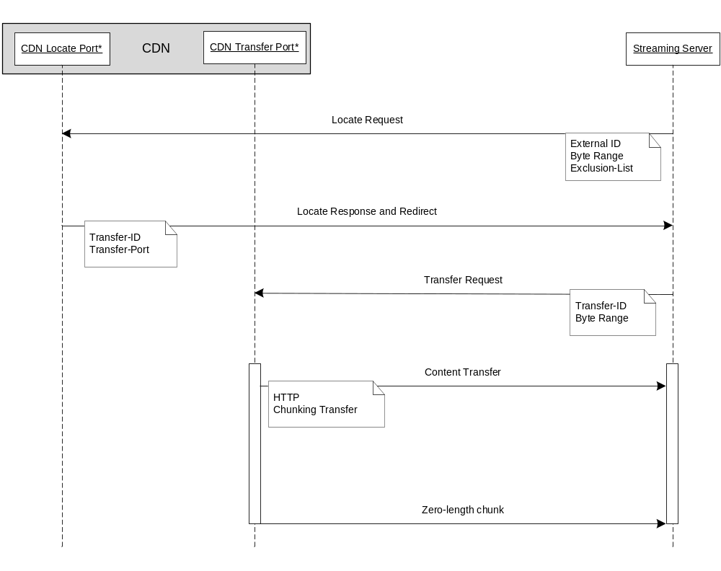

Figure 9. Use Case 1 – Content Locate and Transfer Flow

Figure 10 shows a use case when the client does not initiate a transfer within the 500msec ephemeral lifetime of the Transfer-ID. The CDN will refuse the transfer with an HTTP 404 response code. The client must then perform a new content locate request for the desired object and use the new Transfer-ID and Transfer-Port returned by the CDN Locate Port.
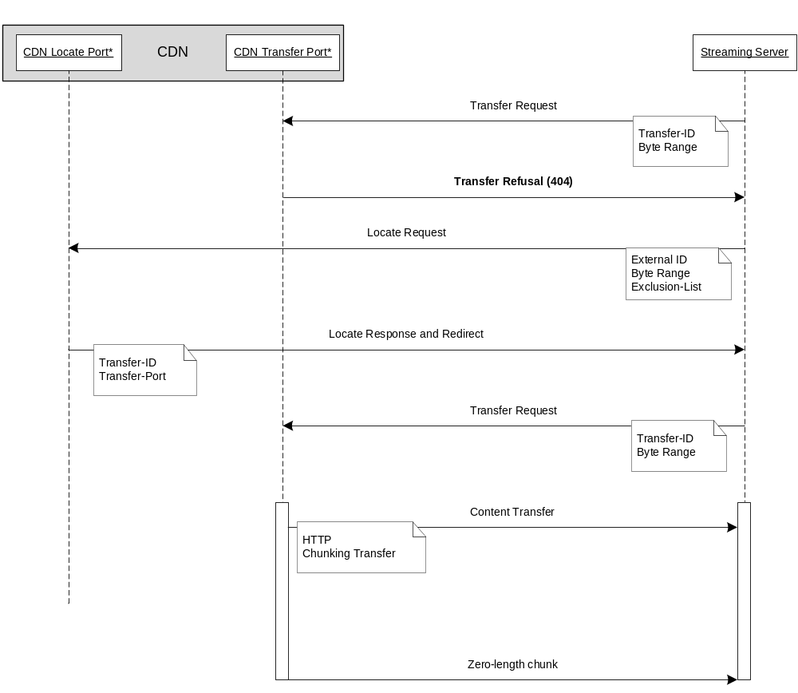

Figure 10. Use Case 2 - Transfer Refusal and Subsequent Locate/Transfer
- Header ABNF
This normative annex gathers together the header ABNF contained in the document.

CR = %x0D
DIGIT = %x30-39 ; 0-9
LF = %x0A
HT = %x09
SP = %x20

CRLF = CR LF

LWS = [CRLF] 1*(SP / HT)

SWS = [LWS]

COMMA = SWS “,” SWS
HCOLON = *( SP / HT) “:” SWS

first-byte-pos = 1*DIGIT
last-byte-pos = 1*DIGIT
suffix-length = 1*DIGIT

byte-range-spec = first-byte-pos “-“ [last-byte-position]
suffix-byte-range-spec = “-“ suffix-length

bytes-unit = “bytes”
c2-byte-range-set = (byte-range-spec | suffix-byte-range-spec)

byte-ranges-specifier = bytes-unit EQUAL c2-byte-range-set
; this value of byte-ranges-specifier differs from HTTP 1.1

ranges-specifier = byte-ranges-specifier
transfer-delay = [-] 1*5DIGIT
; milliseconds from -4000 to 30000

range = “Range” HCOLON ranges-specifier
ingress-capacity = “Ingress-Capacity” HCOLON 1*DIGIT
; bits per second

This is a XML term as defined, http://www.w3.org/TR/2006/REC-xml11-20060816/#dt-chardata

